SLE-3: Architectural Design (Full C4 Model)
Course: 02AML204 — Introduction to Artificial Intelligence
PRN: 25UAM135
Name: Jayat Uttam Magdum
Division: B
Date: 4 October 2026
GitHub Link: https://github.com/jayantmagdum797-collab/IAI_SLE3/tree/main

1. System Title & Short Description
Route-Finding System (BFS / DFS). This is the same system profiled in SLE-2.
The user gives a route map as an adjacency-list graph, a start location (A) and a destination (H). The system searches the graph with Breadth-First Search or Depth-First Search and returns a route to the destination. It also counts the nodes expanded and measures the run time. It solves the problem of finding a valid route, and with BFS the shortest route in an unweighted graph, while comparing both strategies.
2. Context Diagram (Level 1)
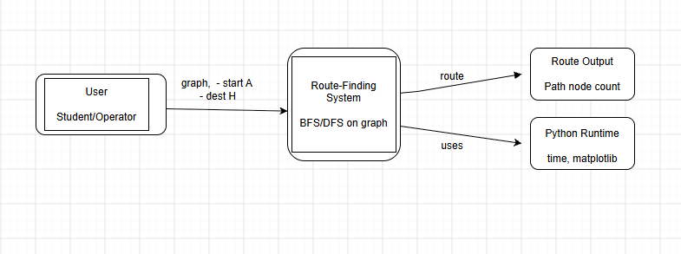
The User gives the graph, start and destination to the Route-Finding System. The system returns the route and the number of nodes expanded. It relies on the Python runtime (time.perf_counter for timing and matplotlib for charts). There are no other external systems, so the context stays simple.
3. Container Diagram (Level 2)
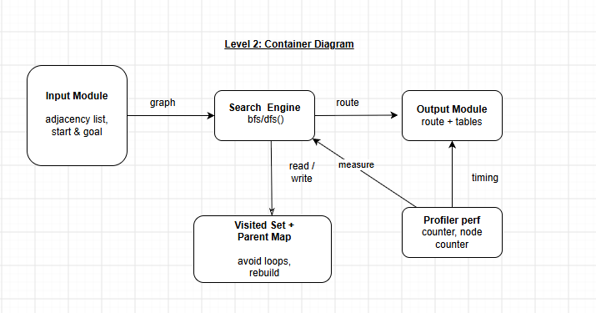
- Input Module: stores the route map as an adjacency list and takes the start and goal nodes.
- Search Engine: runs bfs() or dfs() on the graph and decides when the goal is reached.
- Visited Set + Parent Map: remembers visited nodes to avoid loops and the parent of each node so the route can be rebuilt.
- Profiler: measures average run time with perf_counter and counts nodes expanded.
- Output Module: shows the final route, route length, comparison tables and charts.
4. Component Diagram (Level 3)
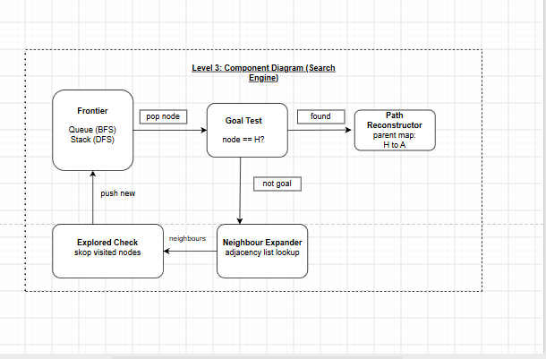
I chose the Search Engine because it holds the core logic. The Frontier is a queue for BFS and a stack for DFS, and this is the only real difference between the two algorithms. The Goal Test checks each popped node against H. If it is not the goal, the Neighbour Expander reads its neighbours from the adjacency list and the Explored Check drops nodes already visited. New nodes go back to the Frontier. When the goal is found, the Path Reconstructor follows the parent map from H back to A.
5. Code Level Overview (Level 4)
- build_graph() : creates the adjacency-list map for each test case.
- bfs(graph, start, goal) : queue-based search; returns the route and nodes expanded.
- dfs(graph, start, goal) : stack/recursion-based search; returns the route and nodes expanded.
- reconstruct_path(parent, goal) : walks the parent map from H back to A and reverses it.
- profile_run() : runs each algorithm repeatedly and records average time.
- plot_graph() / plot_chart() : draw the route graph and timing chart.
6. Design Decisions
I split the system into 5 containers so each part has one job: input, search, memory, measurement and output. Keeping the Profiler separate means the search code stays clean and the timing does not change the algorithm. The parent map is stored during search so the route is rebuilt only once at the end. BFS and DFS share the same structure and differ only in the Frontier, which makes the comparison fair.
7. AI Contribution Note
- AI tools used: Claude (Anthropic).
- What AI helped with: drafting the C4 diagrams, the report layout and the wording of the explanations.
- What I did myself: chose the route-finding system from SLE-2, checked that the containers, components and function names match my own code, and can explain each design choice.
8. Conclusion
This task showed me that architecture is about dividing a system into clear parts and showing how they connect. The four C4 levels let me move from the big picture (user and system) down to individual functions without getting lost. I also learned that a small algorithm like BFS/DFS has a clean structure, and that a good design keeps search, memory, profiling and output separate so each can be changed or tested on its own.

